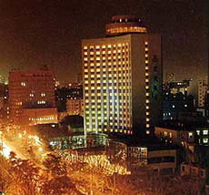
Nanjing Xuanwu Hotel(南京玄武饭店)
Address: No. 193 Zhongyang Road, Nanjing 210009
Phone: 86-25-83358888
ZIP: 210009
Description: The Nanjing Xuanwu Hotel is a five star international hotel that locates besides the scenic Xuanwu Lake. It oppsite the Jiangsu Exhibition Hall and is close to the railway station.ational hotel that locates besides the scenic Xuanwu Lake. It oppsite the Jiangsu Exhibition Hall and is close to the railway station.The location made it an ideal choice for both business and leisure traveler
Location:
Xuanwu Hotel locates in downtown Nanjing. It is 40 kilometers away from the airport and is 2 kilometers to the railway station.
Facilities
Air Conditioned Rooms, Business Center, Beauty Club, Night Club, Restaurant,Business Center, Beauty Club, Night Club, Restaurant,Sauna, Loun
- Air Conditioning  - Bar & Lounge  - Beauty Salon  - Conference Facilities  - Facilities for disabled  - Fitness Center  - Hairdryer in the bedroom  - Money Exchange  - Newsstand  - Internet Access  - Shopping Arcade  - In-room safe  - Refrigerator  - 110 Voltage | - Alarm Clock  - Business Center  - Billiards  - Banquet Facilities  - Complimentary Daily Newspaper  - Coffee Shop  - Coffee/Tea making pot  - Flower Shop  - Laundry  - Mini-bar  - Night Club  - IDD  - Restaurants  - Sauna

